Name:_____________________
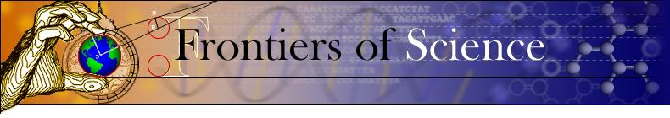
Term Paper Prewriting
Seminar leader: Liz Leininger
Due Friday, April 6th by email
Rename document with your last name, type your answers, and email to ecl2107@columbia.edu

Your term assignment is an analysis of an article from the primary scientific literature (a report that summarizes the data obtained from novel experiments). The following questions are designed to help you think critically and organize your thoughts on your chosen scientific article. You are encouraged to think about all of the following questions before writing your paper, though a subset of them may apply more strongly to your article.

You must answer all questions in bold, plus one additional question of your choosing.

1. a) What is the “big” scientific question or issue you are interested in? Does it relate to something you have learned in Frontiers of Science, or elsewhere in your life (if so, how)?

The big question I’m interested in is how the timing of food intake affects body composition. Because food plays such a big part in our lives people regularly throw around unsubstantiated claims. I want to know if there’s any relevance at all to meal timing. I think there is, but it’s much less relevant than people believe.

b) Oftentimes, big issues need to be addressed in a smaller scope. What is the specific question your article addresses (ie, what is the hypothesis being tested)? How does it relate to the larger question? Does the hypothesis rely on any assumptions?

The specific hypothesis is that timing of food intake is correlated with overall intake. Since overall intake is the only known factor related to body composition, this would create an indirect pathway for late-night food consumption cause body composition changes.

2. Briefly describe the experiment(s) reported in the paper; how were they designed to test the hypothesis?

The paper discusses an observational study. The authors analyzed hundreds of detailed food journals to analyze the correlation between meal timing and overall intake.

3. What scale (spatial or temporal) are the authors of this article working in? Does this scale necessitate particular experimental considerations?

The authors are working with a 24 hour time scale. Because the work is observational, no special considerations were required.

4. Do the experiments described in the article involve proxies? Describe one of the proxies, and what the proxy substitutes for (ie, what the scientists really want to measure). What assumptions did the authors make in using this proxy? Did they present evidence (either data or references to other articles) speaking to the strengths and/or limitations of this proxy? Comment on the strengths and limitations of the proxy.

Total intake can be considered a proxy for weight gain. Current scientific knowledge suggests that net caloric intake is a perfect determinant of weight changes.

5. List 1 - 5 terms from the article whose definitions are unfamiliar and impeding your understanding of the article. (You don’t need to look up the definitions.... yet.)

Didn’t find any.

6. Show me the data!
(i) Insert a screenshot of the most important figure or table (or two) from your article.
(ii) Write a brief description: how are the results described in the paper visually represented in the figure? What comparisons were being made (was there a control group)? How was statistical significance assessed?
(iii) What was the most compelling piece of data reported in the article, and why?

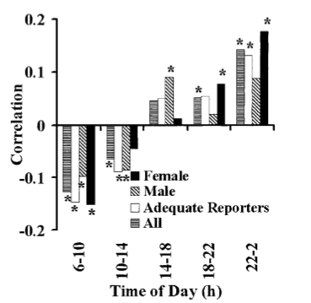
ii. The graph displays correlation between proportion of intake during 5 periods of the day and total intake. Since it’s an observational study, there is no control group. A significance test was performed and p=.01 for all correlations.
iii. This figure displays the most compelling piece of data. There is unequivocally a correlation between total intake and meal timing.

7. If you located your article through the popular media, comment briefly on how well the main question, methodology, claims, and results of the scientific article were described in the column. Describe any discrepancies between the two, and whether reading the primary article changed your opinion of the newspaper column.

This article may not be appropriate for public analysis. The correlation found by the authors warrants further research, but by no means does it prove a causal relationship between meal timing and body composition.

8. Choose a Scientific Habit not addressed in any of the above questions, and briefly describe the application of this Habit to your article.

I think it’s particularly important that the scale of the potential correlation be assessed. Since r is relatively low, meal timing can at best be characterized as a factor weakly affecting body composition if a causal relationship does exist. This article can’t prove the existence of a causal relationship between meal timing and body composition, but it can prove that if one does exists it’s fairly weak.

9. Write the citation for your article below. You must cite your article and include the reference in a Literature Cited section in your final paper. The citation format is as follows:

De Castro, J. M. 2004. The time of day of food intake influences overall intake in humans. Journal of Nutrition 134 (1), 104-111.

